**OFFICIAL COORDINATION REQUEST FOR**

**NON-ROUTINE OPERATIONS AND MAINTENANCE**

**COORDINATION TITLE-** 24JDA08 – Backflushing SFP Intake with Compressed Air

**COORDINATION DATE-** 7/2/24

**PROJECT-** John Day Dam

**RESPONSE DATE-** 7/14/2024

**Description of the problem –** The John Day Project (JDA) has been running a 2-turbine operation for attraction flow at the south fish ladder (SFL) (see MOC: 24JDA01). The turbines have been running at reduced RPMs due to the condition of the equipment. As a result, SFL differentials have been at the lower acceptable criteria range. Any variation in the system may ultimately result in an “out of criteria” operation (OOC). One potential scenario for an OOC is if the intake trash racks (for the AWS turbines) get blocked with debris. JDA has a system to blow compressed air through the backside of the trash rack and help dislodge some of the debris (mostly milfoil and other vegetation).

Unfortunately, in order to use the compressed air clearing method, the turbines must be taken offline for about 15-30 minutes. During this time the SFL would be OOS. JDA would like to perform this operation once/month to prevent any debris accumulation and keep the system running in criteria.

**Type of outage required –** Attraction water will be shutoff to the SFL for approximately 15-30 minutes while the operation is being performed. During this time the North Fish Ladder will remain in service.

**Impact on facility operation –** The SFL AWS pumps will be turned off resulting in a loss of attraction water to the SFL.

**Dates of impacts/repairs –** Estimated outages will occur *approximately*: July 15th (after FPOM), August 1st, September 2nd, and October 1st.

**Length of time for repairs** – 15-30 minutes for each occurrence. The outage will be scheduled between 1200 and 1700 hours to decrease the impacts to fish attraction.

**Analysis of potential impacts to fish-**

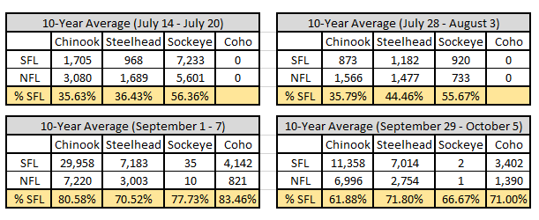

Table 1: The 10-year average for fish passing JDA during the proposed weeks of the compressed air operation and SFL passage percentage.

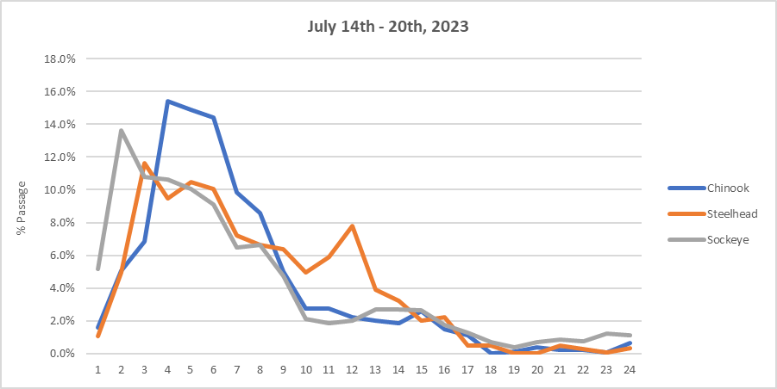

Figure 1: Hourly run times for adult salmonids in the SFL during 2023 proposed compressed air block.

(July 14 – 20, 2023)

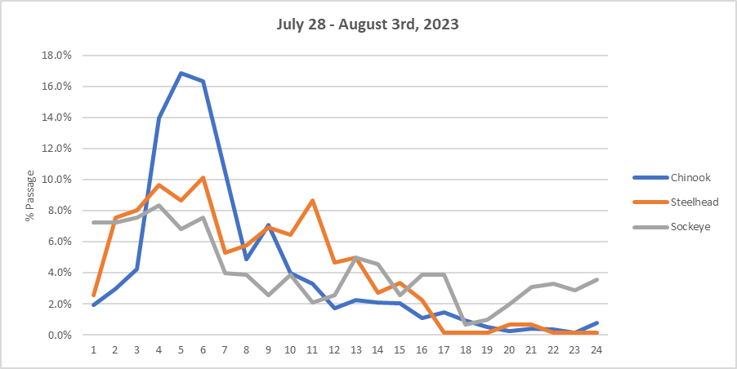

Figure 2: Hourly run times for adult salmonids in the SFL during 2023 proposed compressed air block.

(July 28 – August 3, 2023)

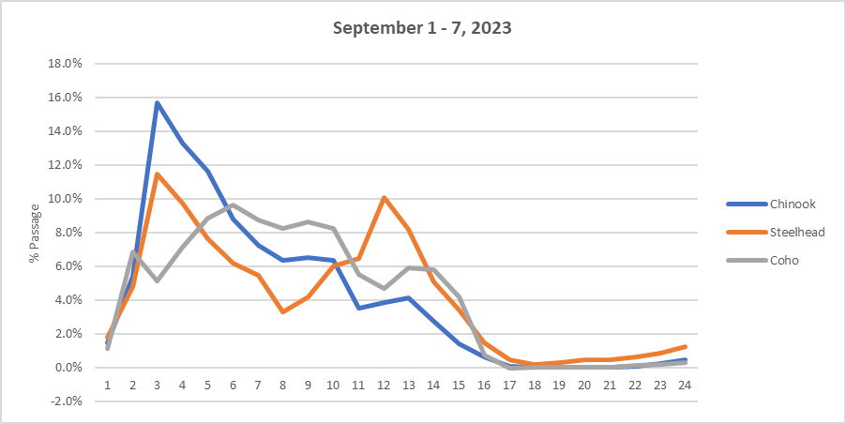

Figure 3: Hourly run times for adult salmonids in the SFL during 2023 proposed compressed air block.

(September 1 - 7, 2023)

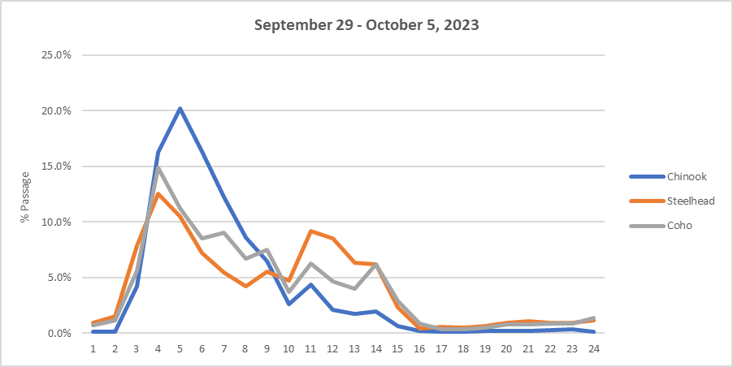

Figure 4: Hourly run times for adult salmonids in the SFL during 2023 proposed compressed air block.

(September 29 – October 5, 2023)

**Summary statement – expected impacts on:**

**Downstream migrants:** There is no expected impact to downstream migrants.

**Upstream migrants (including Bull Trout):** The outage will be scheduled between 1200 and 1700 hours to decrease the impacts to fish attraction. Potential delayed migration due to a lack of attraction water at the SFL. The NFL will remain available for passage.

**Lamprey:**.

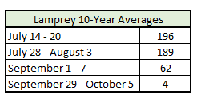

Table 2: The 10-year average for lamprey passing JDA during the proposed weeks of compressed air operation.

**Comments from agencies**

**Final coordination results**

Please email or call with questions or concerns.

Thank you,

David Miller

Chief Fish Biologist

John Day Dam

David.L.Miller@usace.army.mil

541-739-1063